Measuring Your Progress Worksheet
Keep the mission in mind
Your mission is the primary purpose of your department’s existence. When analyzing metrics, keep this in mind so you can prove how your progress is supporting your mission.
Remember your goals and measure accordingly
Goal 1: ______________________________________________________________________________
Goal 2: _______________________________________________________________________________
Goal 3: _______________________________________________________________________________
Strategy – what shapes it? ANALYTICS!
Ex: CSU Athletics and ticket sales
Metrics: Where do I find this data?
- Facebook Insights in the admin panel
- Twitter – www.ads.twitter.com - Analytics menu
Collecting the data
Methods of Collection
- CSV files – excel spreadsheets that give you data set for every single category that is covered
- Manual entry – a method that takes time, but allows for data you want to know
  - Ex. 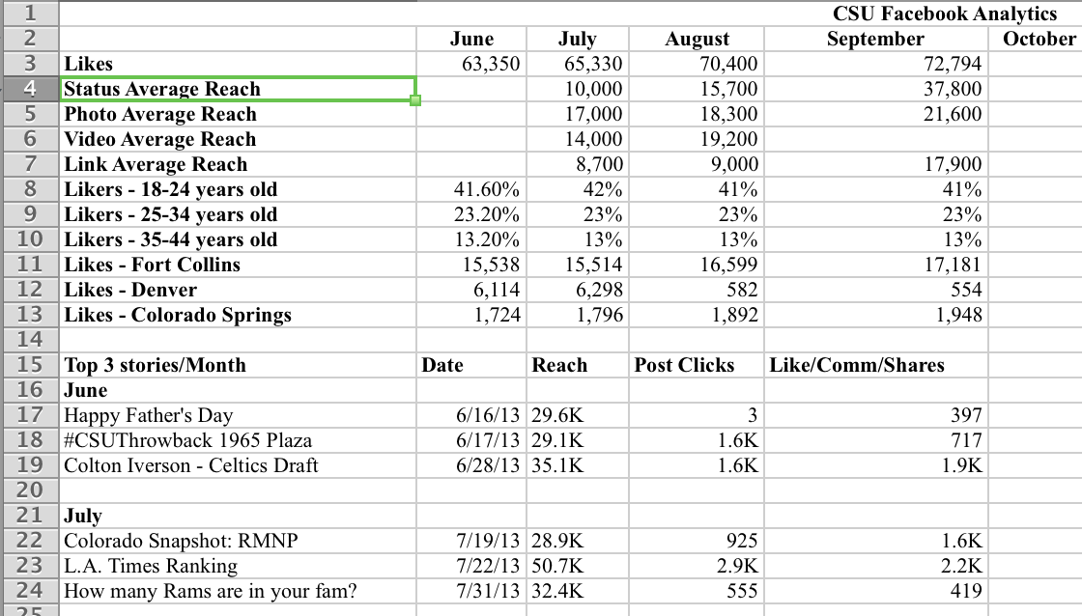

Analyzing the data
List your audiences. You will have multiple audiences that are going to be who and what you want to tailor your posts to. A couple things to think about when deciding your target audience should be; age, location, and gender.
- ____________________________________
- ____________________________________
- ____________________________________
- ____________________________________
Interactions include activity, engagement, likes, reach, and subscribers, which are all things you should be tracking. Here are some definitions of those terms so you can decide what is important to you.
- Subscribers – the people that want to hear your voice, realize these people want to hear what you have to say
- Activity – the content you’re posting for fans
- Engagement – the activity garnered on your posts and page including comments, likes, retweets, follows, replies, and shares.
- Reach – the number of people who see your post whether it’s through organic sharing or paid advertising
- Visits – how people are seeing your page, is it via mobile, desktop, or their own timeline
Some things to think about when looking at your accounts analytics
- What are your social media goals? Position your metrics to support them.
- Think about how you or your organization defines success for your social media channels (is it in number of subscribers? Activity? Interactions?)
- Don’t forget to consider how to assess the overall health of your social media channels (are they active and thriving? Is participation growing, declining, or stalling)?
Timing
Timing has become vitally important for all social media platforms all across the board, especially Facebook. Knowing the times and days your followers and “likers” are on is vital to the success of your post.
What day of the week is your busiest? _____________________________________

What times do you see peeks of activity on each day of the week?
- Sunday _________________
- Monday __________________
- Tuesday __________________
- Wednesday ___________________
- Thursday __________________
- Friday __________________
- Saturday __________________
Identifying Content to Share
Now you can consider sample content. When creating content don’t forget all of the previous information you have about your missions, goals, audience, and platform, in addition to social media best practices.
How would you describe your unit’s voice/personality on social media?
_______________________________________________________________________________________________________________________________________________________________________________________________________________________________________________________________
What topic area “buckets” can you develop content from and share with your audience(s)?
- ____________________________________
- ____________________________________
- ____________________________________
Measuring your progress
How will you measure your progress? _______________________________________________________________________________________________________________________________________________________________________________________________________________________________________________________________
What are the best platforms to reach each audience? Will effective communications require multiple accounts? Examples -
- Office of Admissions – they have an Instagram account which is great because the largest demographic of users of that platform are 14-17 y/o
  - Athletics has an Instagram account because people love sports pictures
- CSU has a Google + account because it’s a large enough entity to draw interest on that platform and it’s another way to connect to fans that choose other platforms.

Identifying your resources
List the resources available to your department to meet social media communications goals:
Staffing__________________________________________
Hours per day/week________________________________
Budget for paid promotions or contests________________
Departments with dedicated communications professionals will approach their goals very differently from those without. How do your resources change how you approach your goals? Will you prioritize some and leave others for later?
_______________________________________________________________________________________________________________________________________________________________________________________________________________________________________________________________
Thanks for attending the October/November 2013 Social Media Workshop
Feel free to reach us at socialmedia@colostate.edu

